Project C: 3D World

Name: Mingyang Li

netID: mlr1159

To illustrate a 3D world, I assume that the view is acquired from a flying camera, which fulfill the Canonical View Volume of the WebGL.

First of all, my program depicts the 3D scene which fill all the width of your browser window, without any distortion of the images within, even after window re-sizing makes the webpage taller or wider. It always fills entire window width and 0.75 of the window height. The viewport will show a 3D perspective image with 35-degree vertical field-of-view from a camera location.

Secondly, in the depicted 3D world, there are several kinds of objects. The rooster is flying in this imagine world which is build up by gold material. The sun is moving in the sky which is build up by ruby. The robot is walking on the ground, which is build up by sliver. The star model is demonstrated in the canvas, which is build up by jade. The detector is flying in the imagine world which is build up by copper. All the objects are automatically moving and rotating. Besides, they are animated, adjustable, 3-jointed and 4-segment 3D shape. Moreover, the ground is made by blue and green material.

In addition, there are two lights in the imagine world. One is a head light which is located at the camera. The camera can be controlled by the user. The other light is the user light which can be adjust the location by the user, not only by the input blank but also by the mouse drag. Besides, the ambient color, diffuse color and specular color can also be changed by the user’s input.

There are some adjustable 3D view controls in this project.

If you press the key of H, you can open a new webpage of user instruction to get some information of this project.

If you press the key of u, i, o, p, you can change the lighting condition and shading condition from phong lighting with phong shading, blinn-phong lighting with phong shading, phong lighting with gouraud shading to blinn-phong lighting with gouraud shading.

If you press the key of up arrow, you can spin upward the camera to see a different view.

If you press the key of down arrow, you can spin downward the camera to see a different view.

If you press the key of left arrow, you can spin leftward the camera to see a different view.

If you press the key of right arrow, you can spin rightward the camera to see a different view.

If you press the key of <, you can move forward the camera.

If you press the key of >, you can move backward the camera.

If you press the key of W, you can move up the camera.

If you press the key of S, you can move down the camera.

If you press the key of A, you can move left the camera.

If you press the key of D, you can move right the camera.

If you press the key of [, you can spin counter-clockwise the camera.

If you press the key of ], you can spin clockwise the camera.

If you press the key of U, you can spin counter-clockwise the roosters.

In addition, if you drag the mouse, you can change the location of the user light.

Besides, there are several buttons and input blanks below the canvas which can control the computer graphics.

If you press the button of turnONHeadLight, the head light will be turned on.

If you press the button of turnOFFHeadLight, the head light will be turned off.

If you press the button of turnOnAmbient, the ambient of head light will show in the canvas.

If you press the button of turnOFFAmbient, the ambient of head light won’t show in the canvas.

If you press the button of turnOnDiffuse, the diffuse of head light will show in the canvas.

If you press the button of turnOFFDiffuse, the diffuse of head light won’t show in the canvas.

If you press the button of turnOnSpecular, the specular of head light will show in the canvas.

If you press the button of turnOFFSpecular, the specular of head light won’t show in the canvas.

If you press the button of turnONUserLight, the user light will be turned on.

If you press the button of turnOFFUserLight, the user light will be turned off.

If you press the button of turnOnAmbient, the ambient of user light will show in the canvas.

If you press the button of turnOFFAmbient, the ambient of user light won’t show in the canvas.

If you press the button of turnOnDiffuse, the diffuse of user light will show in the canvas.

If you press the button of turnOFFDiffuse, the diffuse of user light won’t show in the canvas.

If you press the button of turnOnSpecular, the specular of user light will show in the canvas.

If you press the button of turnOFFSpecular, the specular of user light won’t show in the canvas.

In the input blanks, you can input different value of R, G, B of Ambient, Diffuse and Specular of user light to show different computer graphics.

You also can input the value of X, Y and Z of user light to change the location of the user light.

All input blanks should press the submit button to realize the function.

The following pictures are the results I cut out from the screen.

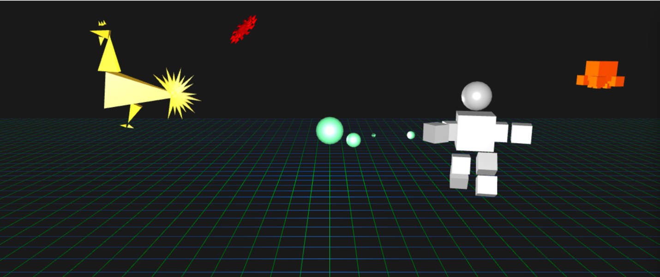

figure1

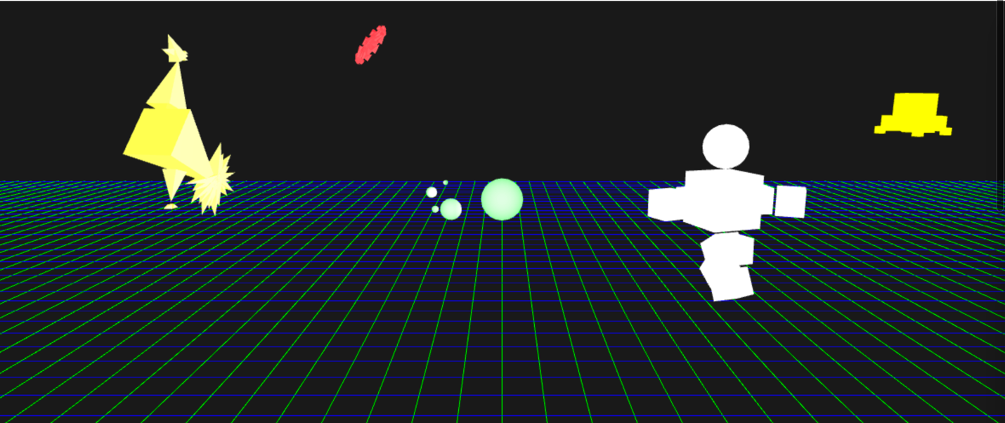

figure2

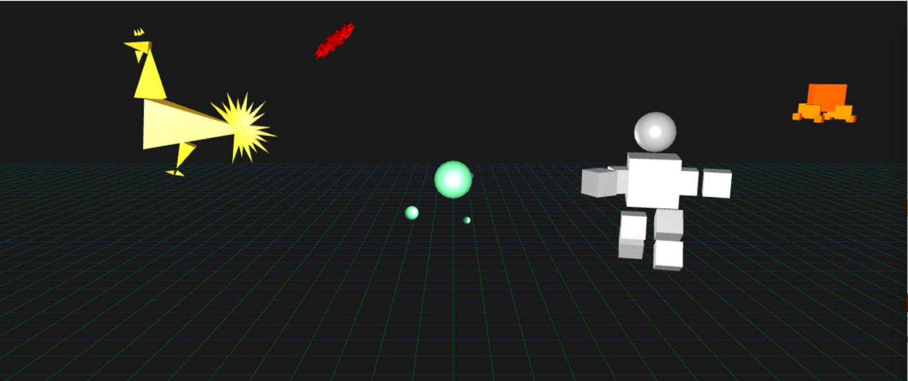

figure3

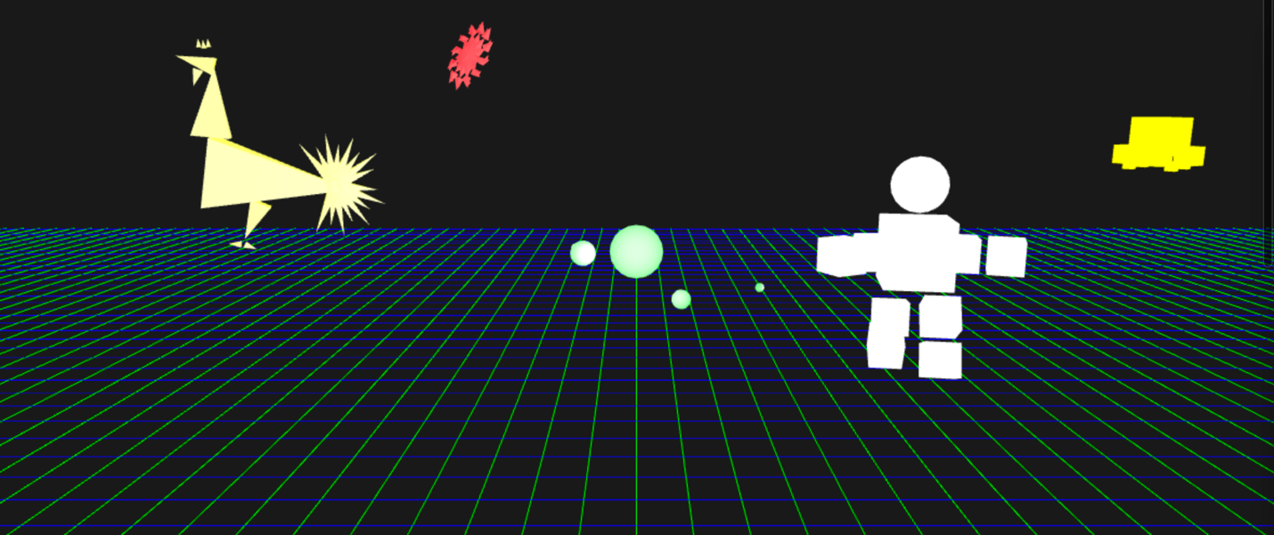

figure4

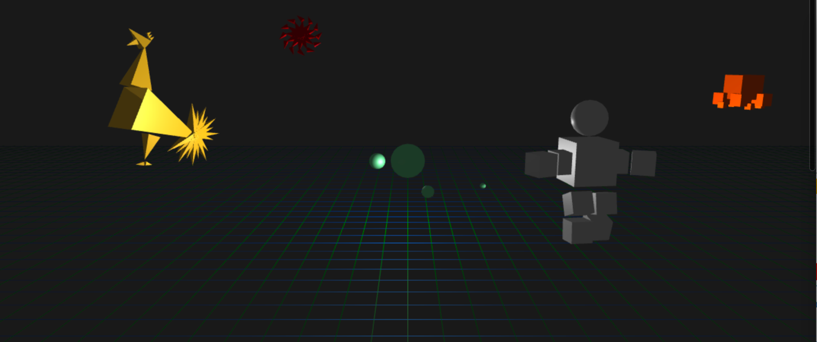

figure5

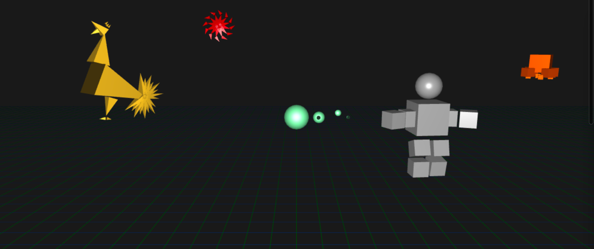

figure6

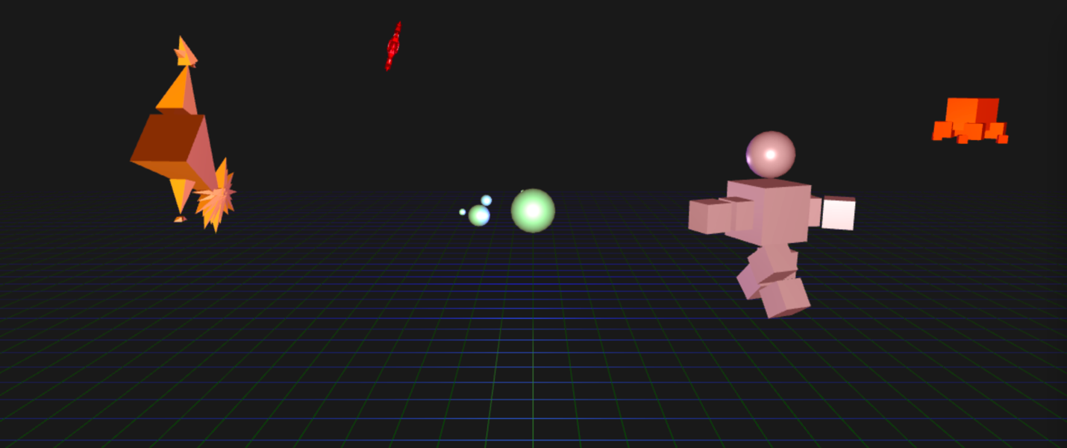

figure7

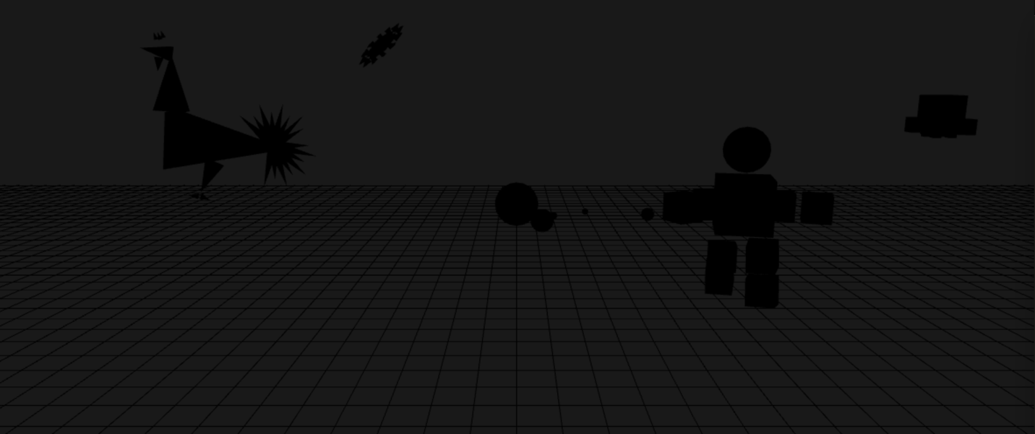

figure8

Following is the program’s scene graphic.

